**2019-2020 NCSLMA Elementary School**

**Region ___**

**Student Name**

PRESENTED TO

**BATTLE OF THE BOOKS**

Certificate of Recognition

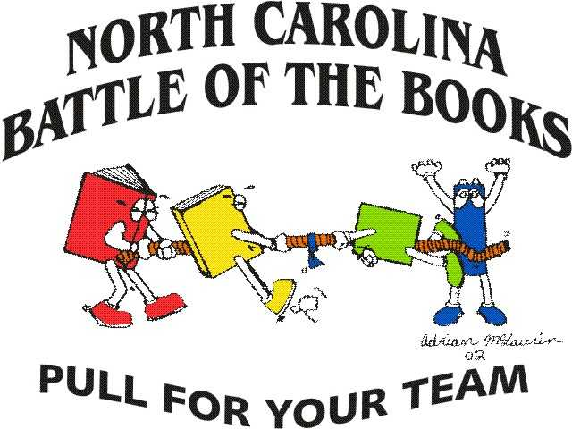

**Coach**

**Coach**

**NCSLMA STATE BATTLE OF**

**THE BOOKS CHAIRPERSON**

Stacy Hersey

**Date**