**2019-2020 NCSLMA Middle School**

**School System**

**Student Name**

PRESENTED TO

**BATTLE OF THE BOOKS**

Certificate of Recognition

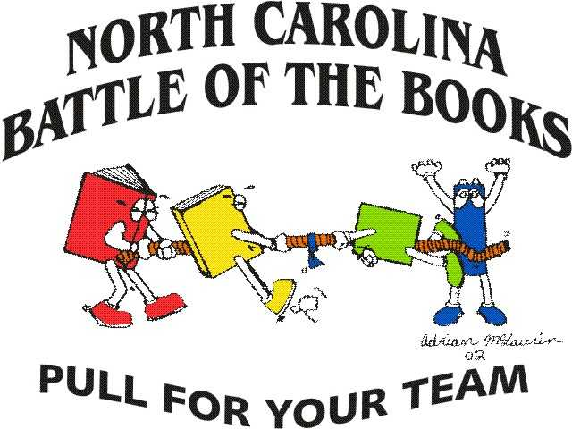

**Coach**

**Coach**

**NCSLMA STATE BATTLE OF**

**THE BOOKS CHAIRPERSON**

Charlene Waller

**Date**